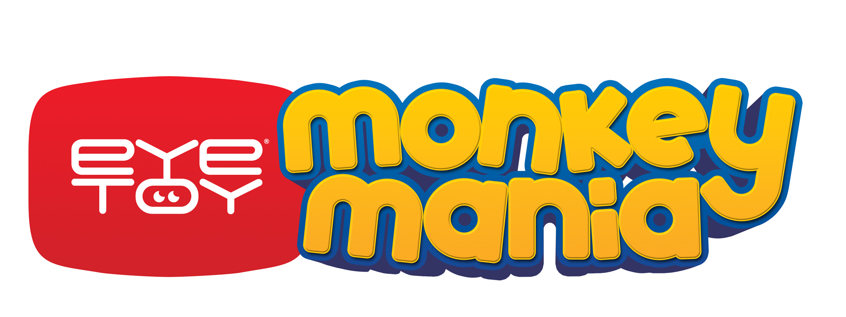

London, November 2004 – Sony Computer Entertainment Europe is pleased to announce the release in PAL Territories of EyeToy®: Monkey Mania, a wacky board game style EyeToy title created by Sony Computer Entertainment Japan (SCEJ) with kids in mind. . .

EyeToy: Monkey Mania on PlayStation®2 is an ideal game for kids and their families. With board game style play you can spin the roulette wheel and move around the course of Bubble Island encountering penalty squares, traps, bonuses and all manner of unexpected obstacles. The game is full of cheeky monkeys who you must befriend and use as currency, but it’s not always easy as you’ll never know when they’ll strike with their mischievous ways! Some of these squares will lead you to one of 50 fantastic and fun mini games.

By using the EyeToy USB Camera (for PlayStation 2) (EyeToy Camera) you really can see yourself (and as many as three friends) on screen, games like bomb hockey enable you to smash the puck into your opponents net and knock their monkey characters off their feet! The EyeToy Camera projects the players onto the screens to physically interact with the characters and environments of the game in real-time and players can use any part of their body to control the action.

The mini games can be played either on their own or from within the board game and are full of cheekiness synonymous with these monkeys, the games range from guiding a huge snowball along a mountain path, to running like the wind or jamming with your mates in a music session. You can even encourage your in-game character to eat his bananas in class and risk the wrath of the teacher!

Developed by the team at SCEJ responsible for the phenomenally successful Ape Escape™ series, EyeToy: Monkey Mania embraces all the quirks and traits of the wacky characters and puts a stamp of quality to this, their first EyeToy game.

A beautifully designed title that’s gloriously fun. EyeToy: Monkey Mania has bright and colourful graphics, fantastically silly gameplay and is every bit as crazy as kids will want it to be!

For more information on SCEE titles, please visit our website
www.playstation.com

or contact your local PR Manager

Developer: SCEJ Genre: Multiplayer EyeToy Board Game No. of Players: 1-4 Platform: PlayStation®2
Peripherals: Analog Controller (DUALSHOCK®2), Memory Card (8MB) (for PlayStation®2),
EyeToy® USB Camera (for PlayStation®2) Release Date: Spring / Easter 2004

Sony Computer Entertainment Europe Ltd.
Sony Computer Entertainment Europe, based in London, is responsible for the distribution, marketing and sales of PS one and PlayStation 2 software and hardware in 102 territories across Europe, the Middle East, Africa and Oceania. At the end of September 2004, over 39 million PlayStation units had been shipped across these PAL territories, over 100 million worldwide. Between its European debut on 24 November 2000 and the end of September 2004, over 25 million PlayStation 2 units have been shipped across the PAL territories, over 74 million world-wide, making it one of the most successful consumer electronic products in history.

PlayStation, PS one, and the PlayStation logo are registered trademarks of Sony Computer Entertainment Inc. EyeToy is a registered trademark of Sony Computer Entertainment Europe. Ape Escape and related marks are trademarks of Sony Computer Entertainment Inc. All other trademarks are property of their respective owners.

More information about PlayStation products can be found at http://www.scee.com and www.playstation.com.

